Fall Un-Conference:
Integrating Civics in the Social Studies
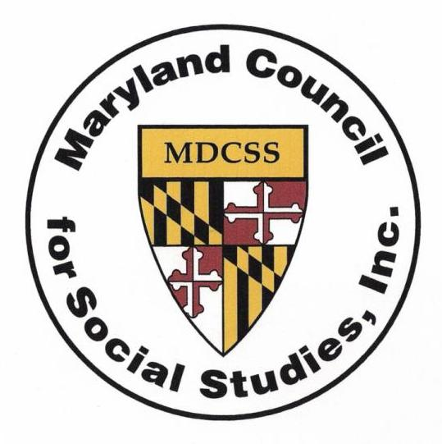

Friday, October 18, 2019
Johns Hopkins, Columbia Campus

Conference-at-a-Glance

8:30 – 9:00 Registration, exhibitors, and breakfast

9:00 – 9:15 General meeting and MDCSS updates

9:20 – 10:15 Session 1

10:30 – 11:25 Session 2

11:30 – 12:15 Lunch and special presentation: Student Panel on Civic Engagement

12:15 – 12:45 Take a break and visit the exhibitors

12:50 – 1:45 Session 3

2:00 – 2:55 Session 4

@MDCSSTalk Maryland Council for the Social Studies www.mdcss.org
Session 1
9:20 - 10:15
213 | Standing for Equality: Where Have We Been, Where Are We Going?  Gary Homana, Marcia Vandiver, Morna McDermott; Towson University  Engage in discussion of a powerful film preserving the rich narratives of individuals who lived through legalized segregation in America. Asking “Where have we been and where are we going?” Voices of Baltimore: Life under Segregation—are stories of individuals who never expected that their lives would become a testament of resilience and an enduring legacy against oppression—speaking volumes about how our nation, and its people, can become a more tolerant and equitable society. Especially important – while our society has become more ethnically and racially diverse inequalities persist, including a return to increased school segregation and poverty.
214 | Being a Citizen...Literally  Katrina Kearney-Hill  During this session, participants will review a variety of texts (picture books and middle grade novels) that connect to many elementary standards. We will learn about characters and individuals (old and young) who are examples of civics in action. Books shared will address race, culture, geography, First Amendment rights, activism, and the need for rules and regulations. Participants will engage in a “book tasting” to further discuss how texts may be used at their schools or to begin school-based action projects. Comprehension questions and strategies will be shared.
220 | How Can I Spark Curiosity in My Students?  Paige Zimmer; Howard County Public Schools  Ignite curiosity through an Inquiry Design Model focusing on the authentic acquisition and application of both skills and knowledge. The following guiding questions are woven throughout the session: How do we turn mandated curricular topics into questions that kids cannot resist exploring? How can I spark curiosity in my students? Learn realistic examples for implementation in your classroom.
221 | Become a National Geographic Certified Educator  Anastasia Cronin; National Geographic Society  What does it take to transform kids into explorers? Become a Nat Geo Certified Educator to find out. This certification is a free professional development program that supports educators to become innovative leaders who teach students about the world, empowering them to succeed and to make it a better place. Start Phase 1 of the process today, diving into our Learning Framework, which covers the attitudes, skills, and knowledge areas needed to develop an explorer’s mindset. Participants can choose to complete Phases 2 & 3 online, integrating relevant resources into their lessons. Certified educators receive special access to National Geographic education resources and an online community of like-minded peers.
Session 2
10:30 – 11:25
213 | Building Civic Skills and Knowledge with Historical Supreme Court Cases  Jen Wheeler; Street Law  This session from Street Law will help teachers bring interactive, engaging, and inquiry- based strategies to their instruction of six historical Supreme Court cases: Marbury v. Madison, McCulloch v. Maryland, Worchester v. Georgia, Ex Parte Merryman, Dred Scott v. Sandford, and Plessy v. Ferguson. Each case pairs with multiple teaching strategies, including primary source inquiry activities. Though this session is open to all, it is particularly well-suited to teachers of middle school students, for whom the case study materials have designed.
214 | Gamify Civics Instruction with NationStates  Amy and Nate Davidson; Wicomico County Schools  NationStates, an online government simulation game, is an engaging way to integrate civics instruction in the classroom. In the game, students are faced with an array of real-world issues they must examine and debate as they govern their country. In NationStates, policy decisions have direct effects on the citizens - for better or worse. Enliven your classroom and better prepare your students for life long civic duty. Learn how to create a country and class region, foster competition between classes, and participate in lively debate simulations in which you vote on issues and see their consequences.
220 | Celebrating Civic Engagement in 2020: Suffrage Anniversaries for Women and African Americans  David Armenti; Maryland Historical Society  Two significant anniversaries will be celebrated in 2020, both honoring the expansion of one of our nation's most important tools for civic engagement: voting. 1870 marked the passage of the 15th Amendment granting African American men the right to vote, while in 1920 the 19th Amendment did the same for American women. The Maryland Historical Society will share stories, new research, and instructional tools that will enhance educators' ability to address these themes with their students. Join us to learn more about individuals like Margaret Brent, Frederick Douglass, Isaac Myers, Juanita Jackson Mitchell, and other Marylanders who contributed to both movements.
221 | Learn to Discern: Equipping the next generation of Digital Citizens  Matthew Vanderwerff; IREX  Learn to Discern is a media literacy approach developed by IREX and designed for today's world. Unlike traditional approaches to teaching media literacy, Learn to Discern was designed for a polarized, hyperconnected, and impatient world.  Learn to Discern helps teachers address the problems that students face today, such as navigating social media newsfeeds, determining which sources are reliable, distinguishing between facts and opinions, and becoming better digital citizens.
Lunch & Special Presentation
11:30 - 12:15, room 218/219
Student Panel: Experiences in Civic Engagement Programs
Take a break, visit the exhibitors
12:15 – 12:45
Session 3
12:50 – 1:45
213 | Finding and Using Historical Newspapers in the Classroom  Marisa Shultz; Jewish Museum of Maryland  Historical newspapers not only offer a unique look at the contemporary opinions of landmark national and international events, but can also provide a segue into discussions of the rights and responsibilities of American citizens. Learn about the variety of databases available to you and your students, practical classroom applications, and the benefits of using historical newspapers in the classroom.
214 | Teaching About Climate Change in the Social Studies Classroom  Lindsay Bailey, Population Connection  As perhaps the greatest threat to humanity in the 21st century, climate change is cross- disciplinary and is very much a topic for the social studies classroom – geography, history and civics. In this session, engage in activities that examine the historical trends that correlate to climate change (population growth, fossil fuel use, changing land use), and participate in a global simulation activity to compare countries emissions and vulnerability to climate-related risks. Receive electronic lesson plans that adhere to the C3 Framework through inquiry, applying tools for geography and history, gathering evidence and communicating conclusions and action items through group discussion.
220 | Using Your Student’s Curiosities to Do Historical Research and Reignite your Social Studies Curriculum!  Robby May; Alleghany Public Schools  Allegany County Public Schools has designed an incredibly unique secondary social studies course called Historical Research Methods I/II (HRM). The course offers students the opportunity to extend their curiosity beyond the textbook and into a variety of investigation projects conducting work in both the classroom and in the field. Classes have published books and produced documentaries on topics like the opioid epidemic in Appalachia and the Greatest Generation. Unlike other classes, the course is student-led, with the teacher serving as an advisor. The class has its own leadership team and orchestrates the project from start to finish. This presentation will share a variety of resources on what this course looks like and how to set up a course like this (or elements) in your school.
221 | Using DBQs as an Instructional and Civil Discourse Tool  Chip Brady; DBQ Project  This session will demonstrate how to use The DBQ Project DBQs as an instructional, not just an assessment, tool. Teachers will practice the instructional moves needed to reach ALL learners, and dive into the work of teaching source credibility, and coaching students to link evidence to argument. Teachers will learn how to establish multiple opportunities for civil discourse within the DBQ instructional cow. The presentation will also examine how several Maryland districts are using DBQ Project materials to prepare for the upcoming EBAS. Attendees will receive a unit of study and preview access to DBQ Online.
Session 4
2:00 – 2:55
213 | Old Papers, New Politics: Teaching Civics with Library of Congress Sources  Isabella Altherr; Maryland Humanities Council  What is the Teaching with Primary Sources program? How can it help my students connect yesterday to today? Maryland Humanities staff will answer these questions and more in this interactive session. Using the Thinkport Inquiry Kits created with Thinkport and the Library of Congress, attendees will identify historical topics and create a cash research project that makes an argument tying the past to the present.
214 | Develop the Next Generation of Citizens through Empathy, Perspective, and Citizenship  Geoff Howard; Pearson  Make Social Studies come to life for your students by building their capacity to evaluate multiple historical perspectives, while increasing empathy through immersive, inquiry-based learning experiences. This session will demonstrate how you can build relevant connections to the present by immersing students in a source-rich environment of documents, audio/visual resources, and engaging technology. You will see examples from the new Project Imagine program that will help build personal connections to the past and the knowledge necessary to develop informed and engaged citizens.
220 | Using Social Studies Skills and Processes in the Classroom  Leah Renzi, Miriam Bart; Maryland State Department of Education  When students take informed action (dimension four of the C3 Framework), they are fulfilling the promise of inquiry based learning. In this session, participants will see how integrating social studies skills and processes into their planning will maximize student potential and create relevant, engaging learning opportunities for all. Participants will be given a brief overview of how the state of Maryland defines social studies skills and processes. This overview will be combined with exercises that demonstrate how teachers can tap into curiosity and develop inquiry based social studies lessons that culminate with students taking informed action.
221 | Inquiry: The Jazz Age & Taking Informed Action  Glenn Diedrich; McGraw-Hill  Participants will explore the C3 process as they work with a blended learning model in order to share with students options to see the importance of The Jazz Age in thoughts and ideas today. The session will also provide the opportunity for teachers to learn about a targeted and personalized reading process, LEARNSMART, using technology to ensure success for all students.

THANK YOU TO OUR SPONSORS

 | 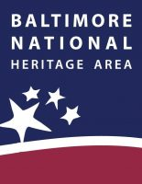
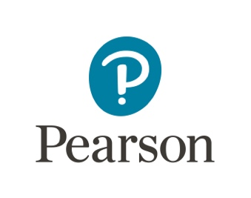 | 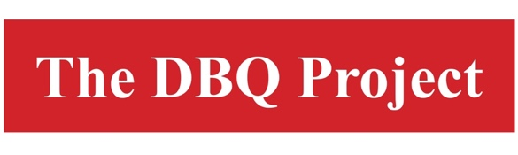 | 